Using InDraw software to Rapidly Convert Image Structures to SMILES
1. Software Installation
Download and install the InDraw software via the https://www.integle.com/static/indraw.
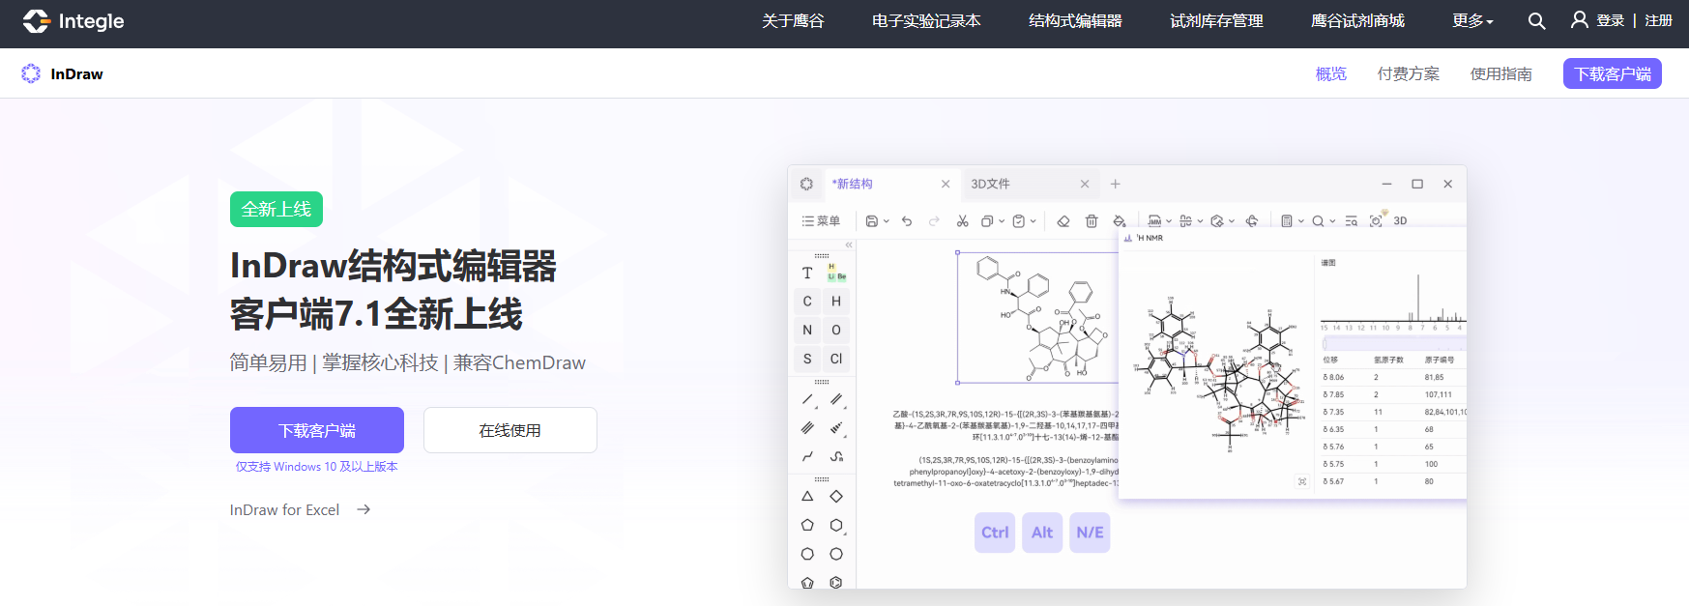
2. Structure Localization
Upload the PDF document and use PSprompt to locate the target chemical structure in large language models such as ChatGPT.
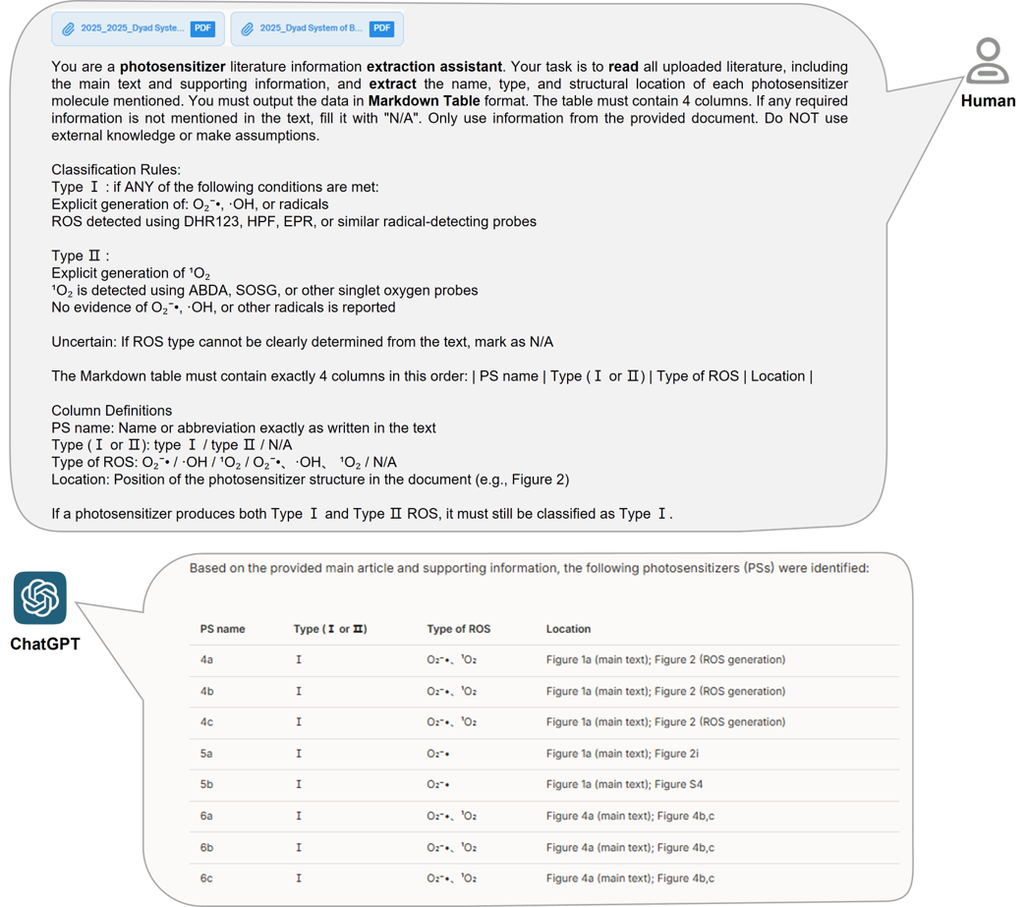
3. AI Image Recognition
Use InDraw's image recognition function to automatically convert structural images into an editable molecular graph.
1) Copy the image to InDraw, then right click and select AI图像识别 (AI Image Recognition).
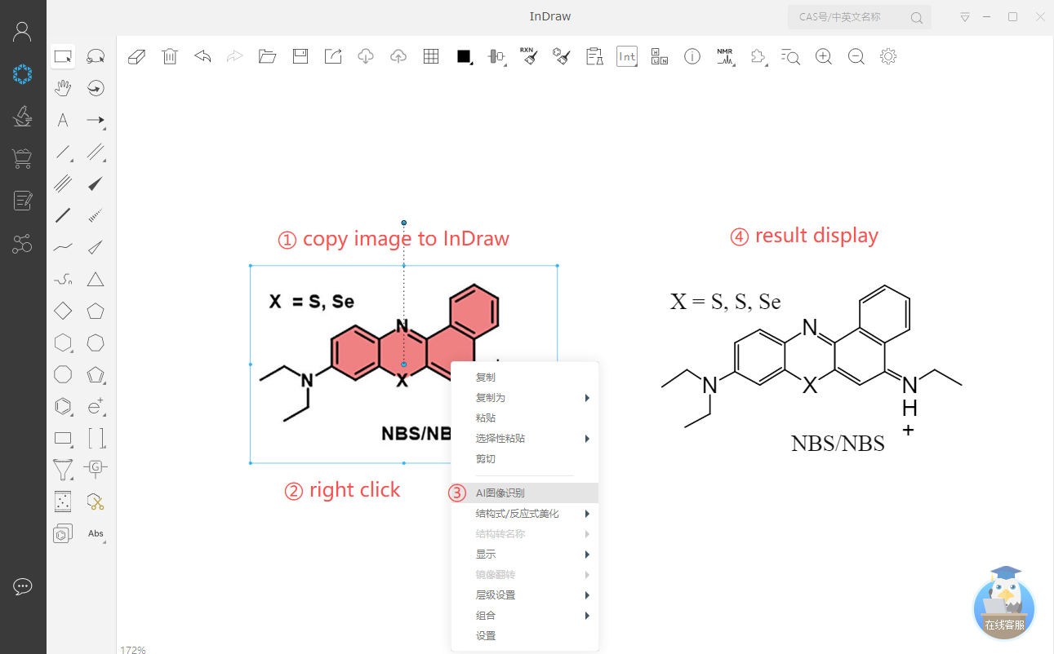
2) Click AI图像识别 (AI Image Recognition) and take a screenshot for recognition.
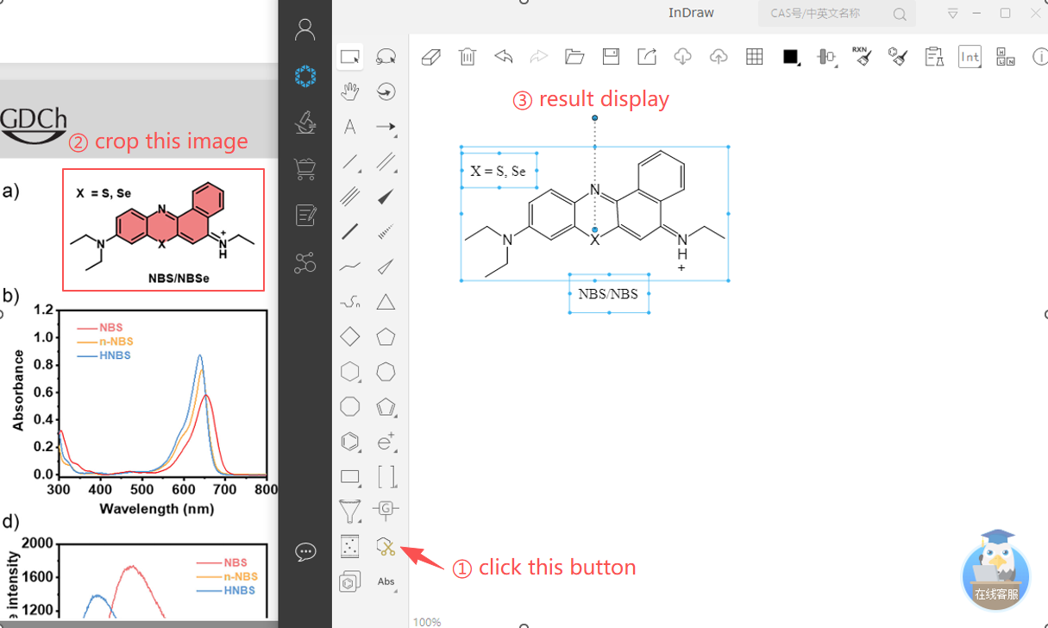

4. Human-Assisted Inspection
Manually inspect the recognized structure and correct any errors in atoms, bonds, or stereochemistry.
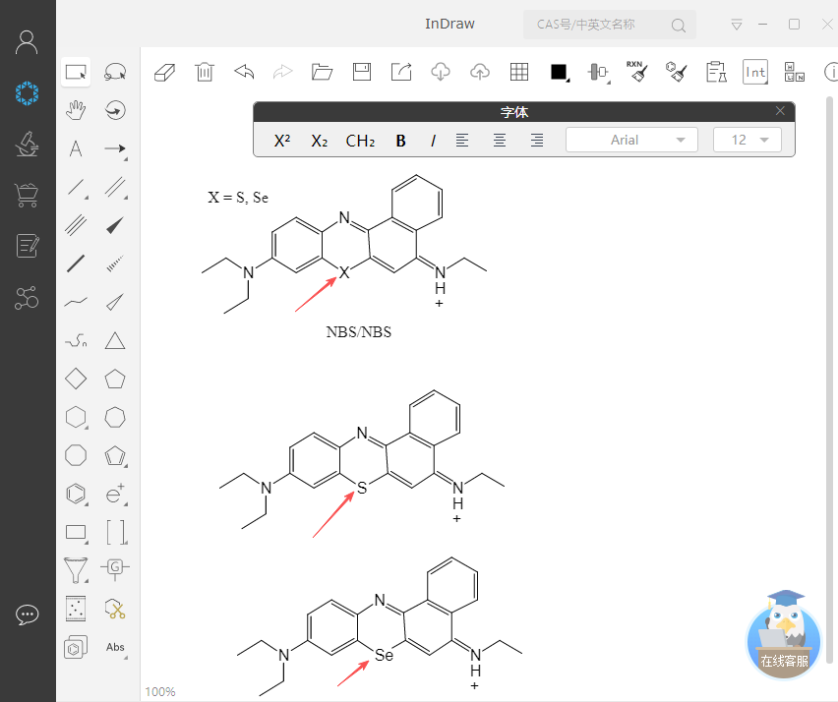

5. Convert Molecules to SMILES
Select the verified molecule, and right click→复制为 (Copy As)→SMILES, or directly use the shortcut keys “Alt+Ctrl+C” to obtain the SMILES string.
